Part 1

1. Update the Employees table, so it contains the HireDate values from 2017 till the current (2021) year.



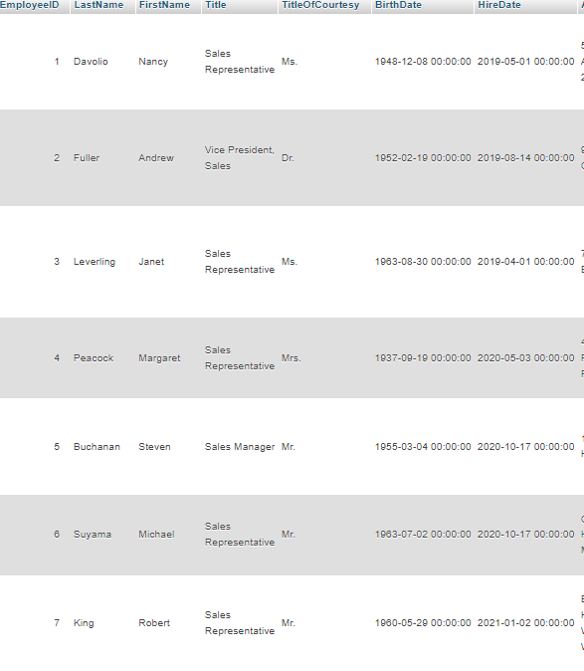

1. Delete records from the Products table which weren`t ordered.



1. Get the list of data about employees: First Name, Last Name, Title, Hire Date who was hired this year (2021).



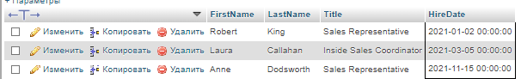

1. Find quantity of employees in each department. Note: Departments is the same as a title in the Employees table.



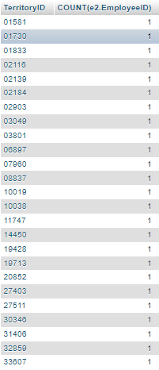

1. Get the list of suppliers, which are located in USA and have a specified region.



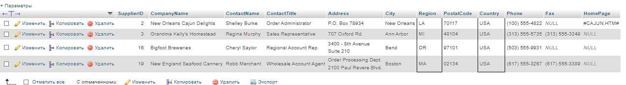

1. Get the amount of products that were delivered by each supplier (company), which have a discount from the Unit Price more than 10%. Where record are represented from the biggest to lowest discount.

[SELECT](http://localhost/phpmyadmin/url.php?url=https://dev.mysql.com/doc/refman/5.5/en/select.html) p.ProductID, [count](http://localhost/phpmyadmin/url.php?url=https://dev.mysql.com/doc/refman/5.5/en/group-by-functions.html#function_count)(*) 'amount_of_products', od.Discount FROM `order details` od INNER JOIN suppliers s INNER JOIN products p ON od.ProductID = p.ProductID [AND](http://localhost/phpmyadmin/url.php?url=https://dev.mysql.com/doc/refman/5.5/en/logical-operators.html#operator_and) od.Discount > 0.1 [AND](http://localhost/phpmyadmin/url.php?url=https://dev.mysql.com/doc/refman/5.5/en/logical-operators.html#operator_and) s.SupplierID = p.SupplierID GROUP BY p.ProductID ORDER BY od.Discount DESC

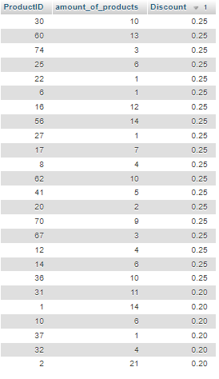

1. Get the top five product categories with the list of the most buyable products in Germany.

[SELECT](http://localhost/phpmyadmin/url.php?url=https://dev.mysql.com/doc/refman/5.5/en/select.html) products.CategoryID, products.ReorderLevel, orders.ShipCountry FROM products INNER JOIN orders INNER JOIN `order details` ON products.ProductID = `order details`.ProductID [AND](http://localhost/phpmyadmin/url.php?url=https://dev.mysql.com/doc/refman/5.5/en/logical-operators.html#operator_and) orders.ShipCountry = 'Germany' GROUP BY products.CategoryID ORDER BY products.ReorderLevel DESC LIMIT 5

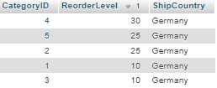

1. Get the First Name, Last Name and Title of Managers and their subordinates.

[SELECT](http://localhost/phpmyadmin/url.php?url=https://dev.mysql.com/doc/refman/5.5/en/select.html) managers.FirstName AS Manager_FirstName, managers.LastName AS Manager_LastName, managers.Title AS Manager_Title, sub.FirstName AS sub_First_name, sub.LastName as Sub_LastName, sub.Title AS Sub_Title FROM employees managers JOIN employees sub ON managers.EmployeeID = sub.ReportsTo ORDER BY managers.EmployeeID

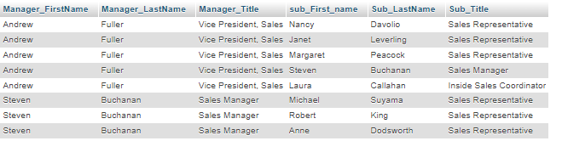

1. Get the Firts Name, Lastn Name, Title of Sales who has the least amount of orders. (Amount of sold products should be also in the result set).

[SELECT](http://localhost/phpmyadmin/url.php?url=https://dev.mysql.com/doc/refman/5.5/en/select.html) e.FirstName, e.LastName, e.Title, [COUNT](http://localhost/phpmyadmin/url.php?url=https://dev.mysql.com/doc/refman/5.5/en/group-by-functions.html#function_count)(o.OrderID) 'amount_of_sales' FROM orders o INNER JOIN employees e ON o.EmployeeID = e.EmployeeID GROUP BY e.EmployeeID ORDER BY [COUNT](http://localhost/phpmyadmin/url.php?url=https://dev.mysql.com/doc/refman/5.5/en/group-by-functions.html#function_count)(o.OrderID) LIMIT 1



Part 2

1. Clone data from the Shippers table to the NewShippers table.

[CREATE](http://localhost/phpmyadmin/url.php?url=https://dev.mysql.com/doc/refman/5.5/en/create-table.html) [TABLE](http://localhost/phpmyadmin/url.php?url=https://dev.mysql.com/doc/refman/5.5/en/create-table.html) NewShippers [SELECT](http://localhost/phpmyadmin/url.php?url=https://dev.mysql.com/doc/refman/5.5/en/select.html) * FROM shippers

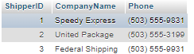

1. Get the list of suppliers which are related to each product name which has price greater than or equal 15$. ( Which information about supplier will be present in result set is optional)